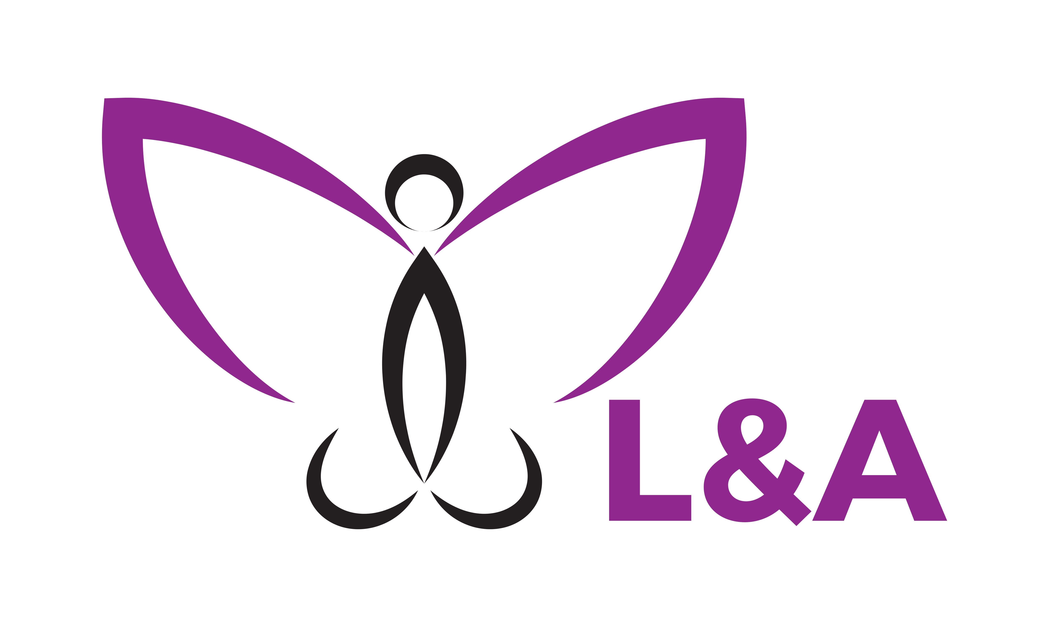

Website: www.landahealth.com

Email: info@landahealth.com

Phone: 0411551984

Fax: 08 9463 6395

Employee assistance programs (EAP) are designed to assist individuals in the workplace with regards to their mental health and any workplace difficulties, both at home and at work. Generally when there is a problem in the workplace, this will be transferred to the home and then the issue or circumstance becomes worse affecting not only their family but also their work colleagues.

Due to the duality of the work and the home place, EAP is often the best assistance you can give your employees, a platform, a medium to which they can discuss situations, which are causing distress and upset.

L&A EAP program is an effective counseling platform, easy to access and utilize to which can assist and enhance your employee's mental health and experiences. When your employee’s mental health is enhanced so is their performance.

Employee Assistant Program

L&A Health

# EAP Programs and its benefits

### The benefits to an organization having a platform and organisation for employees to speak regarding their mental health and work is tremendous.

In recent findings, around 50% of managers think their team is not affected by mental health however in reality there is $10.9 billion lost every year through sick leave and compensation claims and also reduced productivity due to poor mental health and well-being.

43% of employees would like to receive more support from their managers however do know how to best approach their senior leaders or even HR about concerns over their mental well being

#### Did you know

Work stress not only is a frequent problem for employees but also appears to be more and more accepted as part of the price individual’s pay for employment.

Stress management programs are designed to decrease stress to increase our capacity to work effectively.

Mental illness in our workplaces is an all time high. With the current statistic of 10 billion each year spent on stress related compensation claims which have doubled over the recent years, 25% of workers take time off work each year for stress-related reasons, in relation to psychological injury claims, work pressure accounts for around half of the all claims and harassment and bullying for around a quarter of claims.

In general GPs who see 40 patients a day can expect that between eight and ten (20-25%) of these patients will require support or treatment for anxiety or depression, furthermore mental health problems are the third biggest health problem in Australia, after heart disease and cancer.

## The reason for EAP (Employee Assistance Programs)

**How can managers assist?**

* **Promoting EAP programs and assistance to employees**
* **Having meeting discussions in relation to EAP services so employees are knowledgeable and understanding of such service**
* **Having conversations with regards to mental awareness in the organization to promote comfortableness of such discussions amongst peers.**

Results from studies have found statistically significant improvement from pre- to post-EAP service surveys, The American Journal of Psychiatry reports that workplace absenteeism is twice as high for depressed workers and that connecting with mental health experts will increase productivity and decrease job loss whilst also effectively ensuring the financial bottom line remains unaffected.

Usually employees who contact EAP services, may have issues with work related relationships with co-workers or supervisors, diminished work performance, tardiness issues and job-related concerns that present as their main problem/issue.

EAP services will last four to five sessions as needed for the employee. After each session Employees will notice a shift in their perspective about the workplace and can even increase productively due to their new insights. Having an environment that is conducive of understanding and empathy will increase employee performance not only to the employee but as the management as a whole. When employees are happy so are clients and customers.

Top of Form

Bottom of Form

Our Services

What L&A Health provides is access to a health profession trained at and capable of making a difference to anyone who is dealing with work pressures/stress, which may affect family life and their own work performance. As an organisation we aim to provide exceptional service to ensure your employees mental health is put first. We like to work in collaboration with the organisation and assist with best practice with regards to the symptoms your employee's address/present.

For more information please visit our website www.landahealth.com or contact Annabelle Afan on 0411551984

Top of Form

Bottom of Form

## Outcomes of Employee Assistance Program

Check out our website for more information [www.landahealth.com](http://www.landahealth.com) or email us at info@landahealth.com